ATMS Operator Position

There are two TMC Advanced Traffic Management System Operators in the Santa Lucia TMC. These operators monitor workstations from which incidents are detected, traffic flow is monitored, and incident management logs are kept. This information is them disseminated to the other TMC positions. When action is needed, the Changeable Message Signs (CMS) and Highway Advisory Radios (HAR) are activated through the ATMS system.

Advanced Traffic Management System

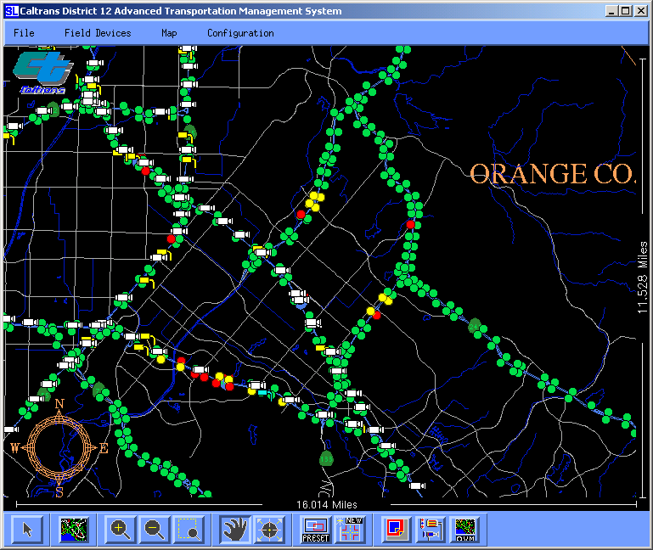
The ATMS is the TMC graphical user interface (GUI) from which incidents are detected, traffic flow is monitored, Changeable Message Signs (CMS) and Highway Advisory Radios (HAR) are activated, and incident management logs are kept. The ATMS works on a mouse point-and-click basis.

ATMS Map Functions
- Green dot – traffic is flowing smoothly (above 35mph)
- Yellow dot – traffic is not flowing smoothly (20 – 35mph)
- Red dot – traffic is not moving (below 20mph)

Adjusting Map View
The map view tool bar is located along the bottom of the ATMS window.
- To zoom in, click the “+” magnifying glass icon, and then click the desired location on the map.
- To set the map view to a desired window, click the icon to the left of the “-“ magnifying glass icon, click the upper-left corner of the desired window on the map, then move the cursor to the lower-right corner, and click again.
- To zoom out, click the “-“ magnifying glass icon, and then click the desired location on the map.
- To reset the map to its default view, click the Map icon to the right of the Arrow icon.
- To select a sensor location, camera, or CMS on the map, click the Arrow icon, and then click the desired icon on the map.

To enter a message on a Changeable Message Sign
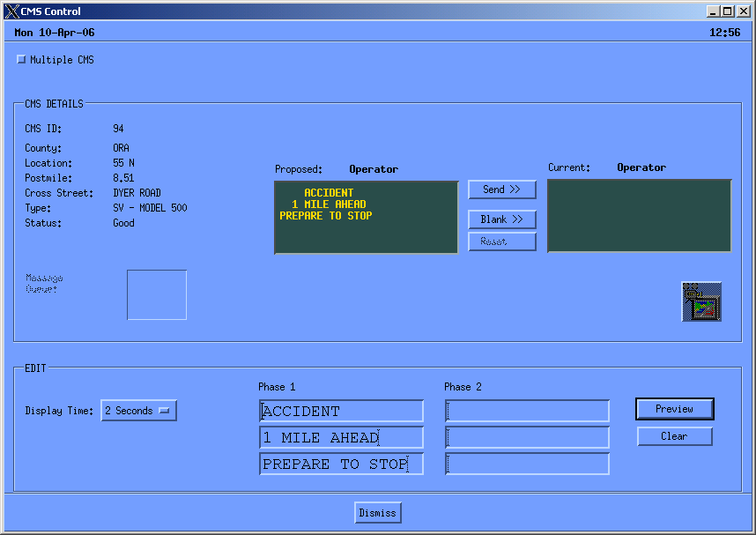
- Left mouse click on desired sign
- Type message in the EDIT box at the bottom of the window. Click “Preview” to check the message.
- Once the desired message has been achieved, click the “Send >>” button to send the message to be displayed on the CMS.

To Exit a window
- Double left mouse click the “-“ button in the top left corner of the window, or click the “Dismiss” button at the bottom of the window.

To exit the ATMS
- Click the “File” menu at the top left of the main window, and choose “Exit”.

